Brief Outline:

Our objective is to highlight how the composition of energy sources has changed over the last several decades. We want to pinpoint Clean Energy and its progress in becoming a bigger piece of the entire energy resource pie.

Link to Main Dataset:

<https://github.com/omaraziz88/Energy-Analysis/blob/master/Enerdata_Energy_Statistical_Yearbook_2018.xlsx>

Below are a few examples of how we envision our visuals to look like. We want to look at production/consumption as part of the total energy mix on a time series basis. We will add visualization enhancements as we see fit as we progress towards our finished product.

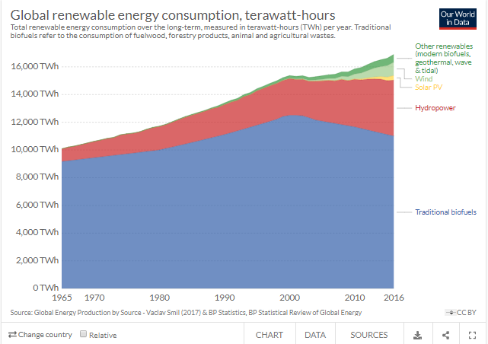

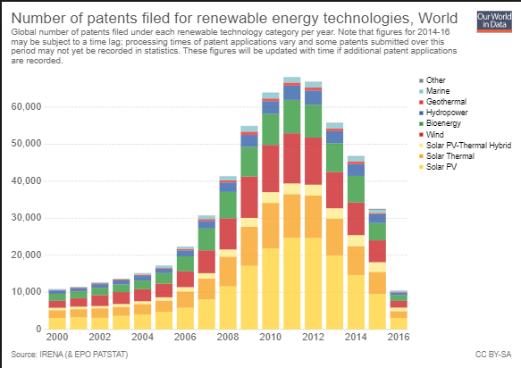

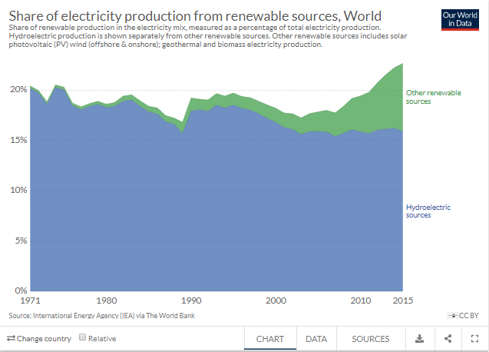

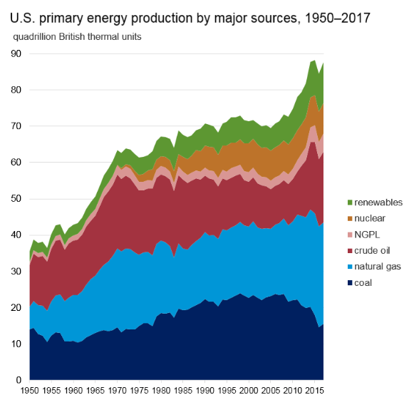

Summarize our findings



Text explaining visual 3

Text explaining visual 2

Text explaining visual 1



Visual 3



Visual 2

Visual 1



TITLE

Intro: Explain our dataset and what we want to highlight in the presentation.

Link to GitHub repository:

<https://github.com/omaraziz88/Energy-Analysis>